3 Spatial Filtering

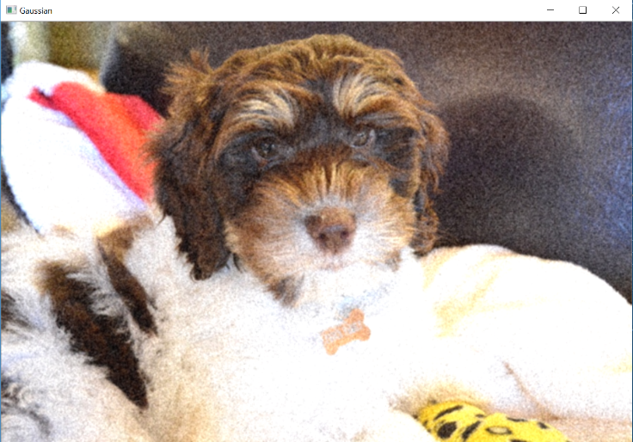3.1 Implementation

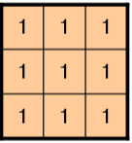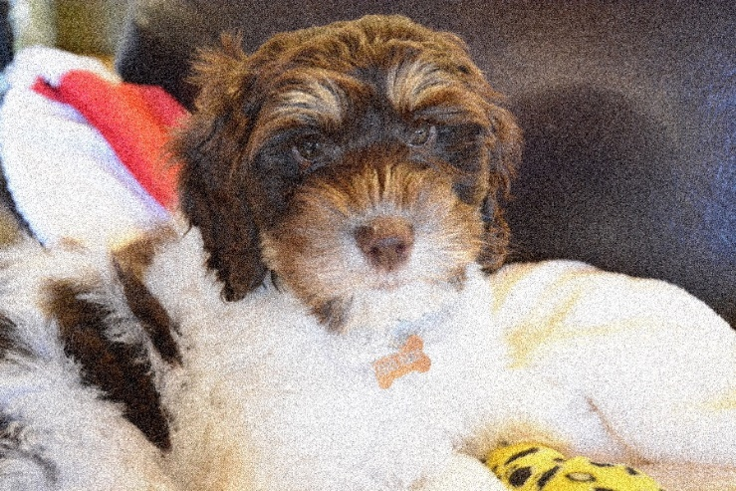Original picture compare to the filtered image.

* The filter I applied to the picture is

3.2 Smoothing, Denoising, and Edge Detection Filters

3.2.1 Smoothing and denoising

3\*3 Gaussian filtered picture

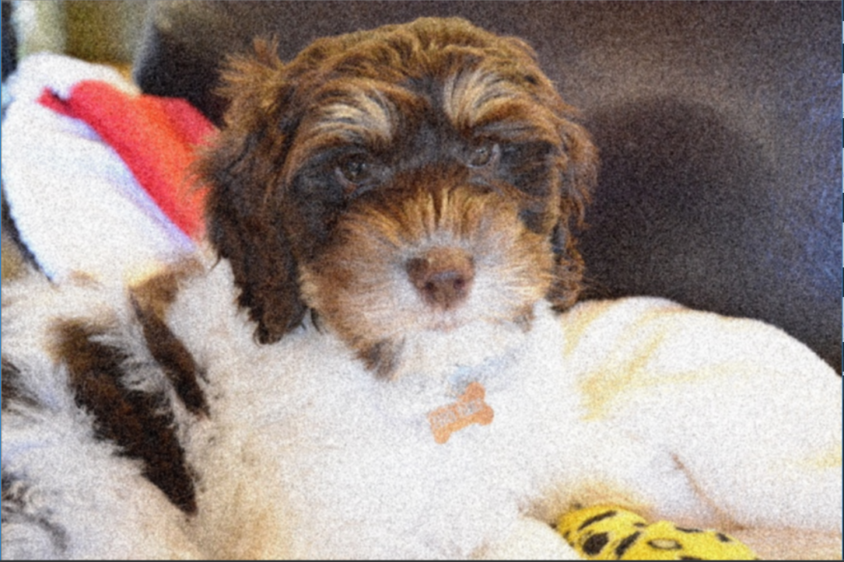

9\*9 Gaussian filtered picture

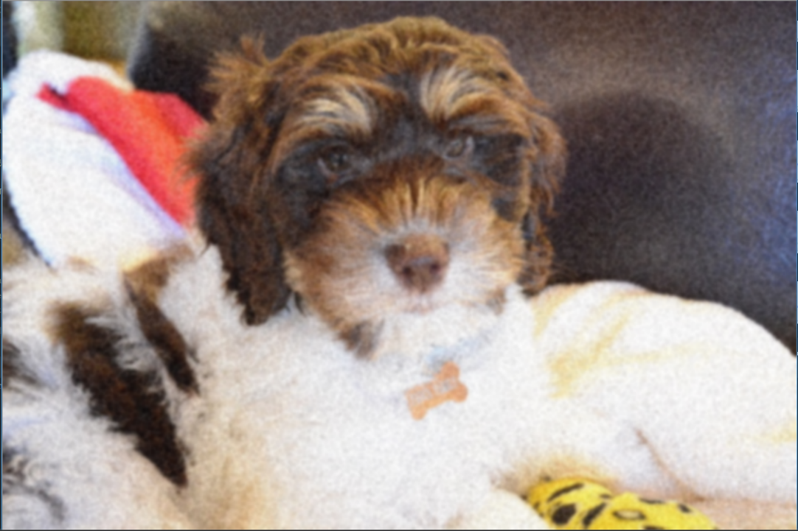

27\*27 Gaussian filtered picture

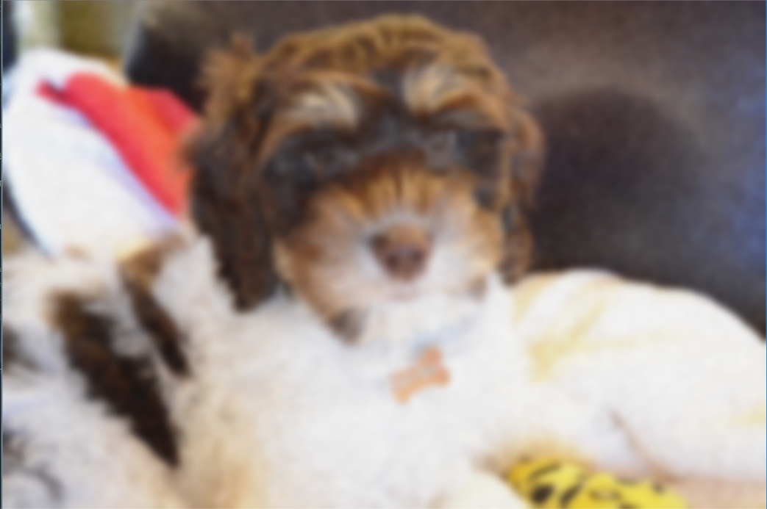

Base on the result I have, I found out that as we are applying Gaussian filter to the picture to make denoise the picture, as the size of the Gaussian filter increase, the picture start to lose edges and details, which means there’s a trade off between the smoothness of the picture and how much details the picture contains.

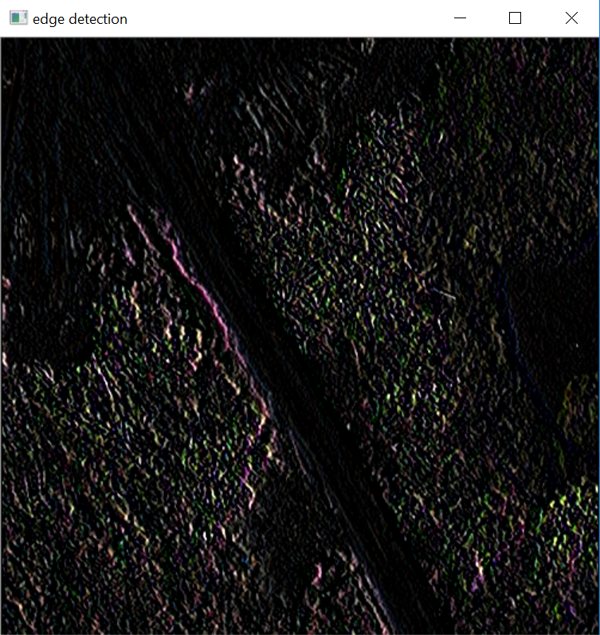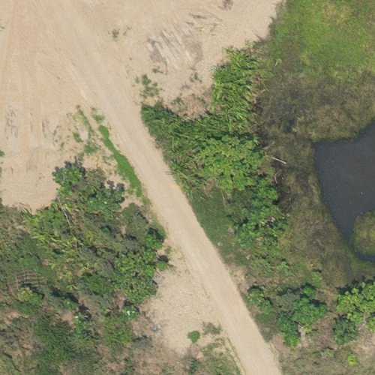3.2.2 Edge detection

I think it will be better if we denoise the picture with smaller size Gaussian filter to prepress the picture first, then to detect edges of the picture.

4 Frequency Analysis

4.1 Implementation

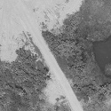The original picture greyscale image

1-D Inverse

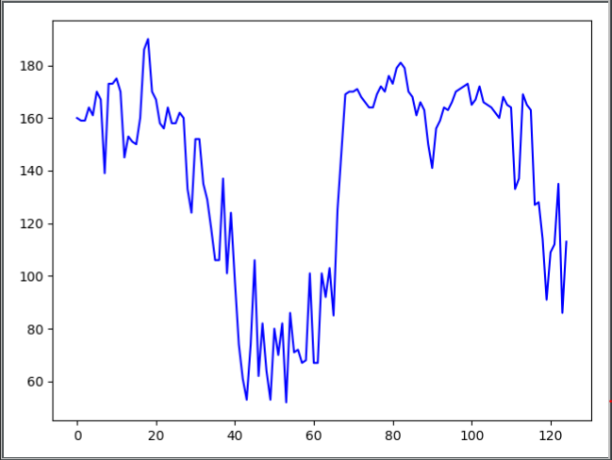

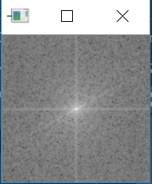2-D Forward Fourier, show the plot as an image (view from top)

4.2 Frequency Analysis

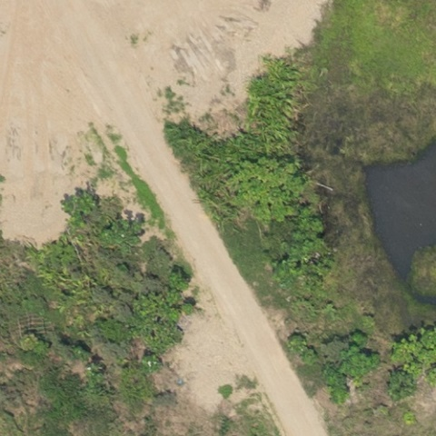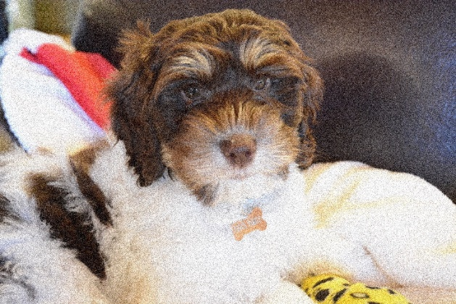

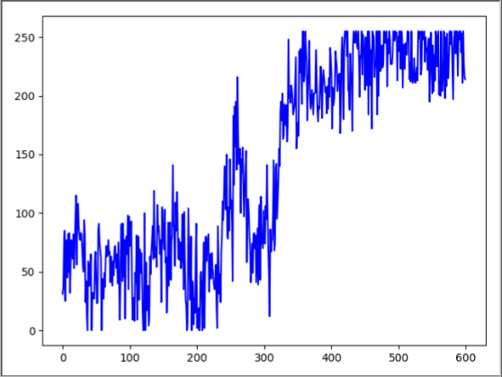

Base on the 1-D Forward Fourier for both pictures, we can realize that the general shape of the line is very different, and that’s because the patterns which were used to build these two pictures are very difference. Secondly, the range for x-axis is much wilder for the dog picture than the field picture. This suggest, it takes more patterns for the system to build up the first picture than the second one. Thirdly, the y-axis for the dog picture is also a lot wider than the y-axis for the field picture. Because the y-axis represented the intensity of that specific pattern.

There is. I applied a gaussian filter to the picture I used for 4.1. This is the 1-D Forward Fourier of the filtered picture.

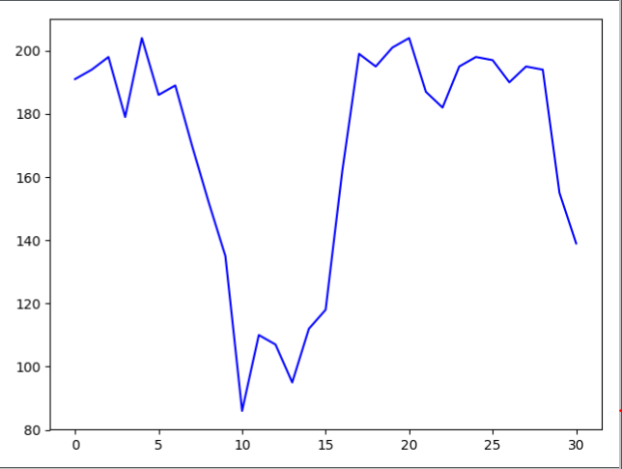

Denoised picture original picture

We can notice that there’s a lot less vibrance in the plot, which means, the variety of patterns that makes the picture is a lot less than the original picture. By applying gaussian filter, we throw away some high frequency features in the picture. Therefore, we can conclude that the noise in the picture brings unnecessary frequent vibrance to the line.

Some log plots of the magnitude of the Fourier coeﬃcients (better seen as images) show higher (brighter) values around the axis, away from the center of the image. Why is that?

All the lighter values in the plot demonstrates higher value in the 3-D log plot. This means there’s certain pattern in the picture that has a very high frequency than others. It could range from some specific boarder for a plane to the collar of a t-shirt.

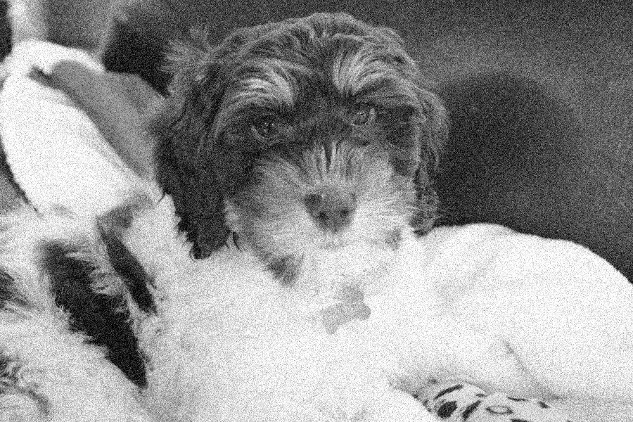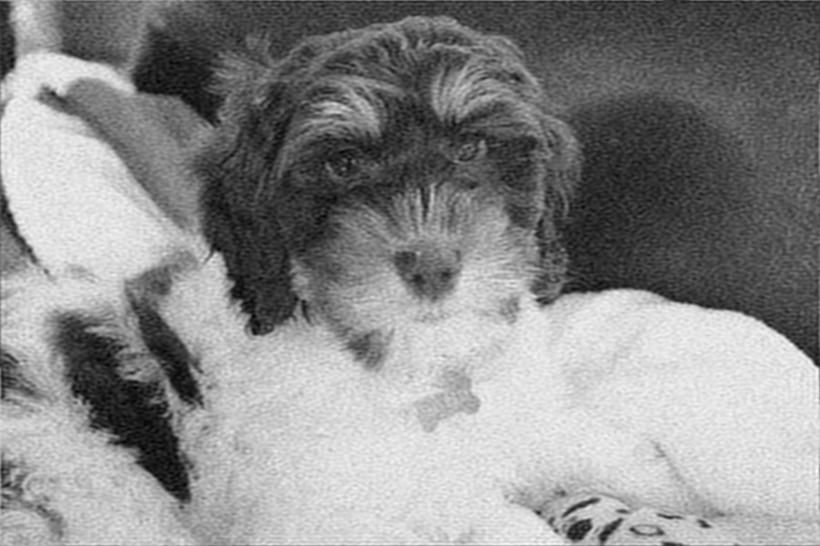

The first picture is the original picture for the dog, the second one is the one we got after applying low pass filter. We can notice that the change for color is a lot smoother for the one with filter. Because a low pass filter only allows low frequency values to pass. Therefore, any frequency that is higher than the filter will be decrease to the threshold. Therefore, what will happened is the edge of the picture will be smoothed by the filter.

5 Frequency Filtering

5.1 Implementation

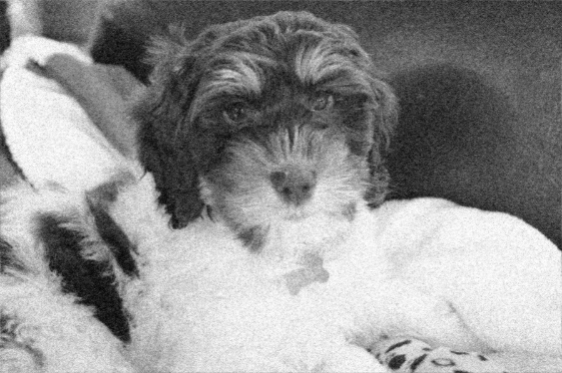

Butter-n1

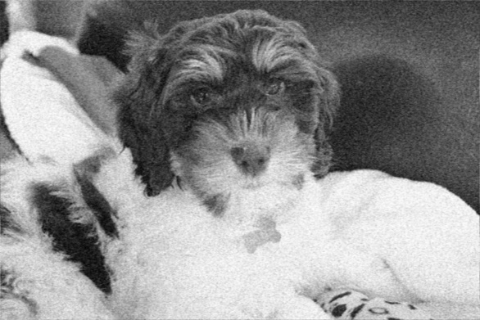

Butter-n2

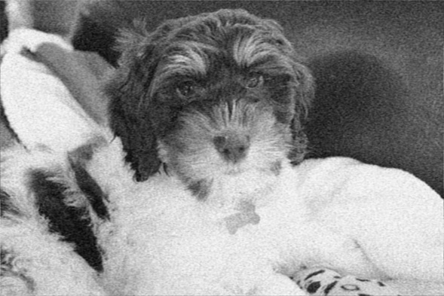

Butter-n3

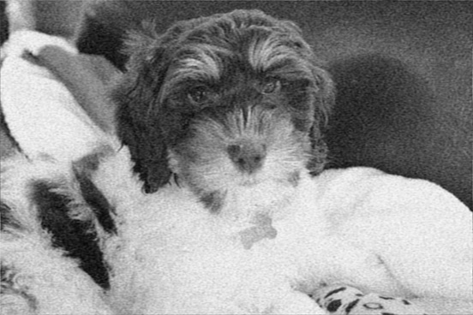

Butter-n4

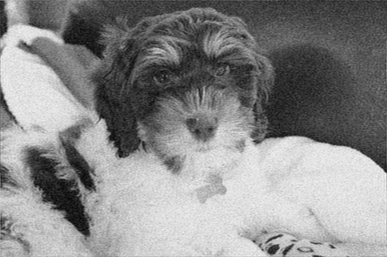

Ideal Low Pass

5.2 Low-pass and High-pass Filtering



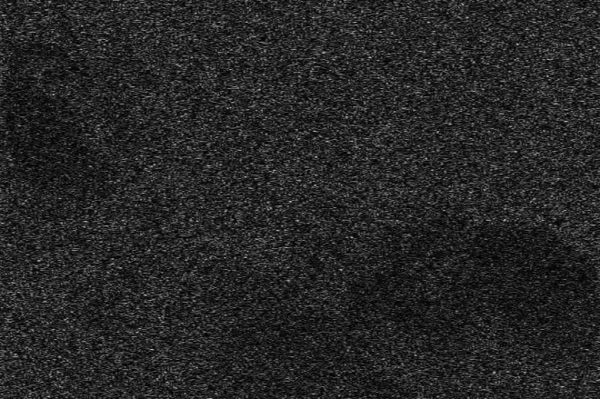This is the high pass filter

This is the picture after the Ideal High pass filter.

We can see that only noises in the picture passed the filter. Because in a picture with object in it, the only pattern that has a very high frequency is the noises(same little dots) in the picture.